Dog Grooming website

Name:
The Royal Groomers

Logo:
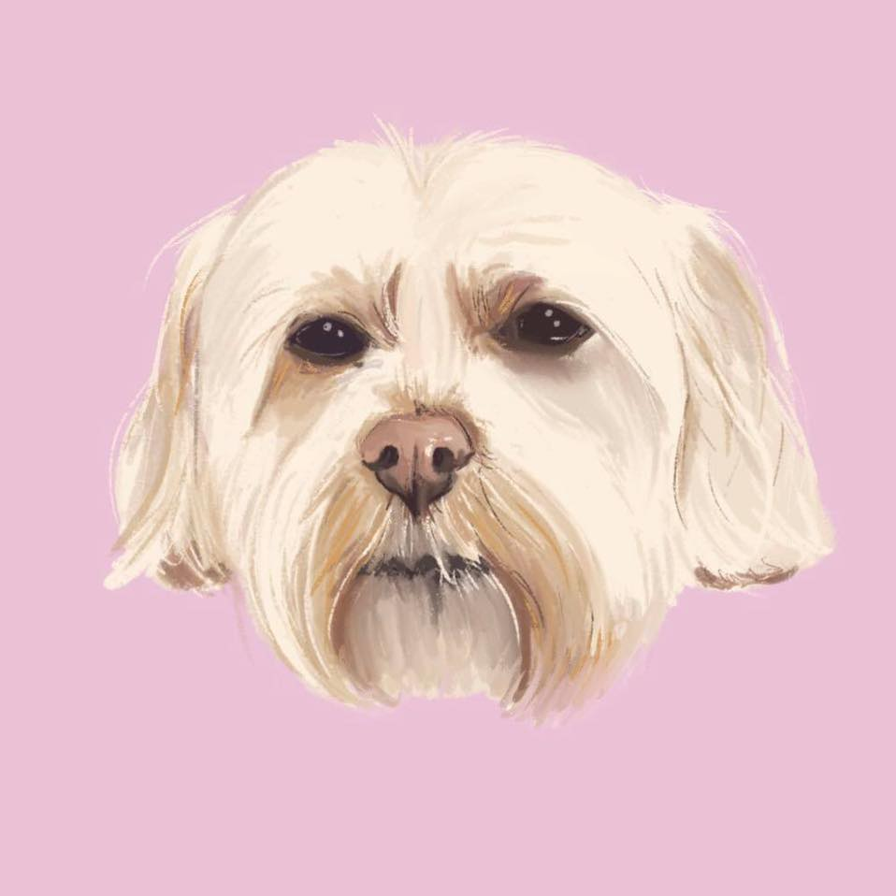

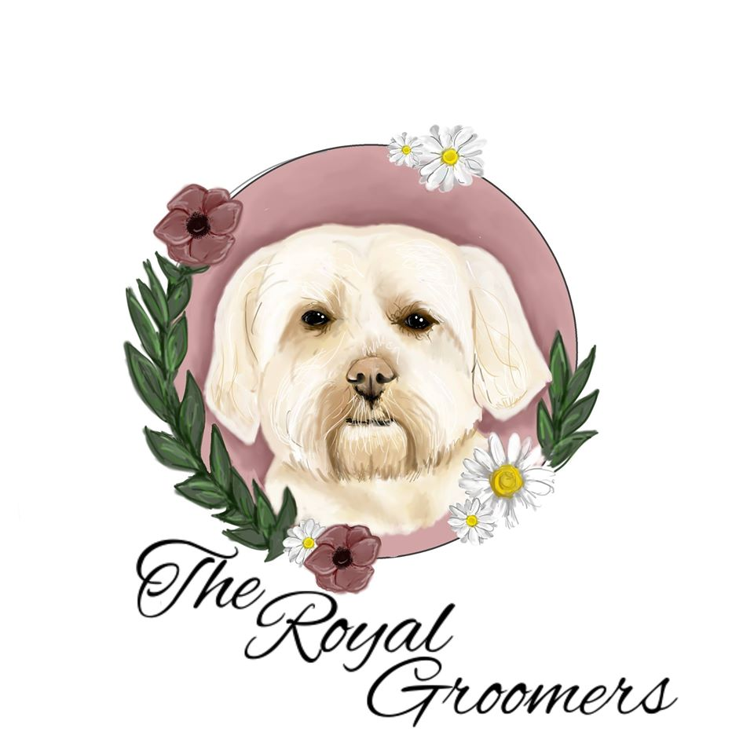

Theme: icons used need to be dog related
Font-family:
Colour scheme: pinks, blues, grey, white warm cute colours
Basic page layout: footer and header along the side fixed will contain social media links

Pages

Home
Near top of home page: A local, affordable, 1 to 1 holistic dog grooming service. I have extensive training with all temperaments and breed types!
Nav bar should have icons

About us and Contact us – use icons for address and phone

Image of employee plus dog – warm looking
Bio comments:

Hello everyone on my Facebook page,
Meet your groomer...
My name is Abby and I have been grooming for 5 years now and I love what I do. I have worked in 7 different salons small and large, meeting all different breeds along the way. I have also been a manager of a large corporate company as well as start up groomer for a small independent salon. I’ve also spent time building my expericace in a vets as a nurse as well as kennels work.
Throughout my training and career working with your beloved pets they have taught me so much💕
I have now chosen to work from home and be a 1 to 1 groomer as I feel it benefits dogs in so many ways🐾 I am thoroughly enjoying all the clients I’m meeting and I’m so grateful for all the support I am receiving. I never imagined I would be this successful In a short space of time.
So i thank everyone who has supported me. As well as all my clients who have brought there fur-babies to me and I hope to see some returning faces as well as new ones☺️

Credentials and past experience
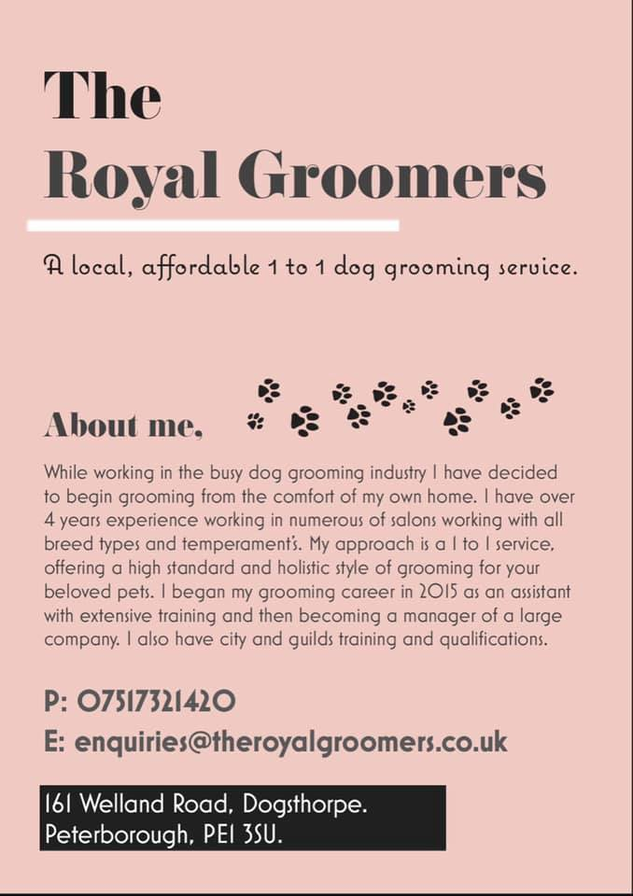

Contact us – use icons for address and phone

Address: 161 Welland Road, Dogsthorpe
Peterborough

Contact number : 07517 321420

Opening hours:
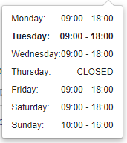
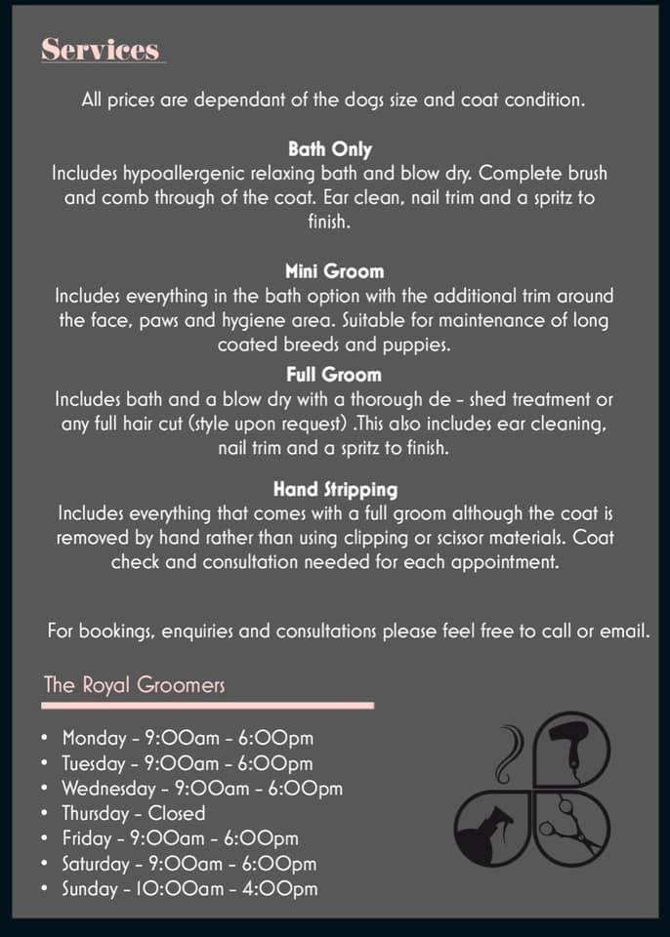

Services

Banner call to check availability or check facebook
Hand Stripping✨
2 hours and over • Price varies
Includes all the services in the full groom service although the coat is removed by hand rather than clipping or scissoring. Coat checks and consultations required.
Mini Groom✨
1 hour and over • Price varies
Includes all services in the bath option with the additional trim around the face, paws and hygiene area. Suitable for maintenance of long coated breeds and puppies.
Bath & Blow Dry✨
1 hour and over • Price varies
Includes a hypoallergenic relaxing bath and a blow dry. Complete brush and comb through of the coat. Ear and nail trim included.
Full Groom✨
1 hour 30 minutes and over • Price varies
a full groom includes a bath, blow dry and brush through. With either a de-shedding treatment or any full haircut. (Styles upon request). This also includes an ear clean and a nail trim.

Needs to include a banner stating: Banner call to check availability or check facebook

Gallery and Testimonials

Images of past dogs before and after
Taken from FB reviews

Accessories

Other items being sold like bows, or toys and so on

